Resource 1: Resource 2:
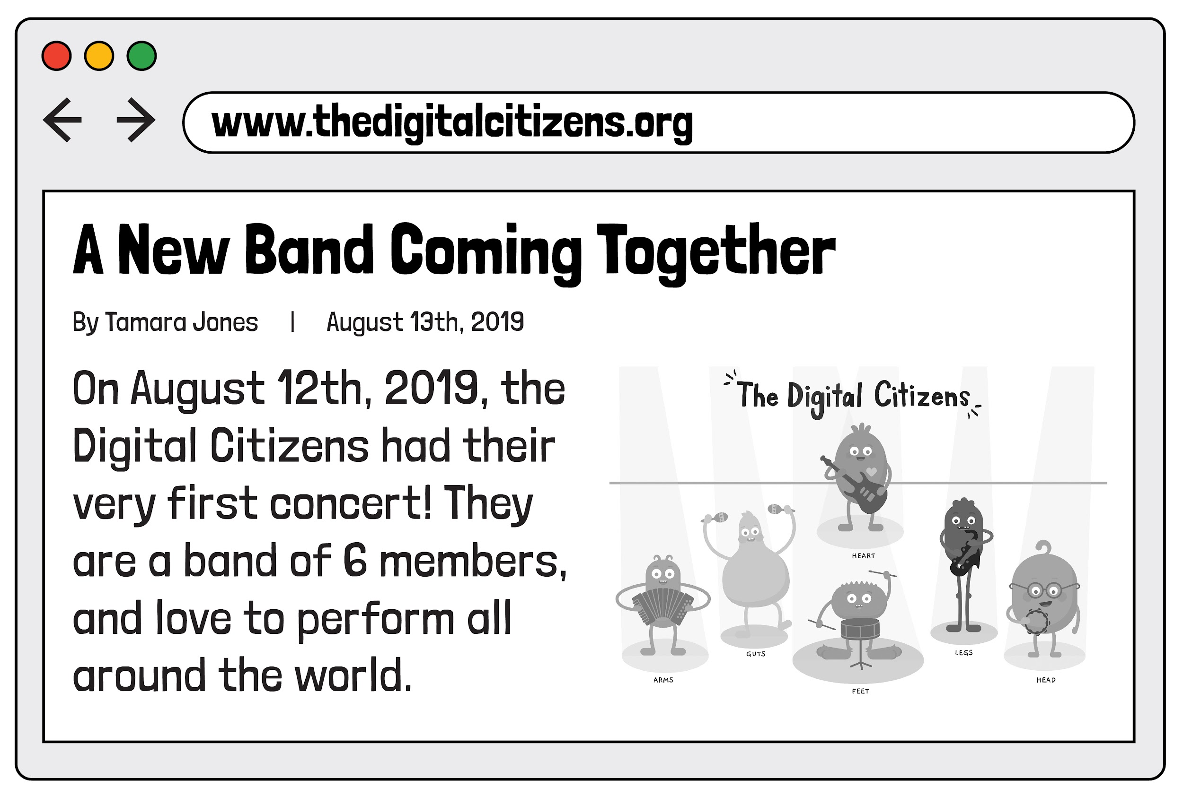
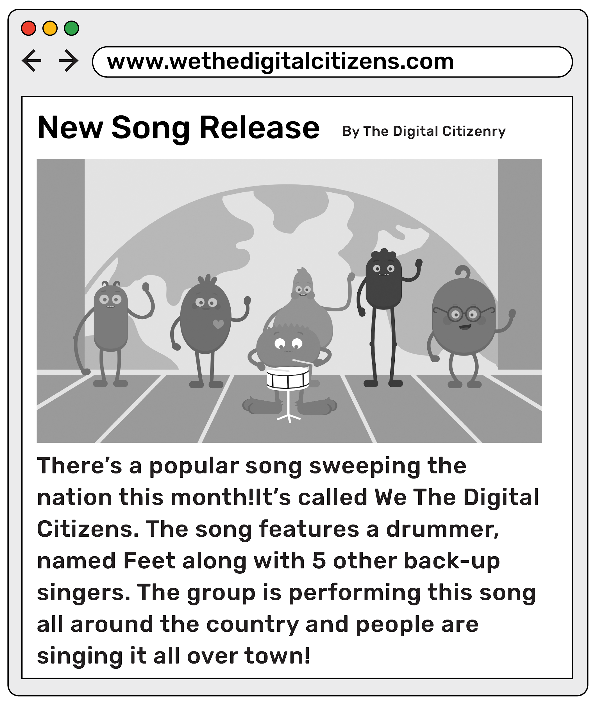
Resource 3:
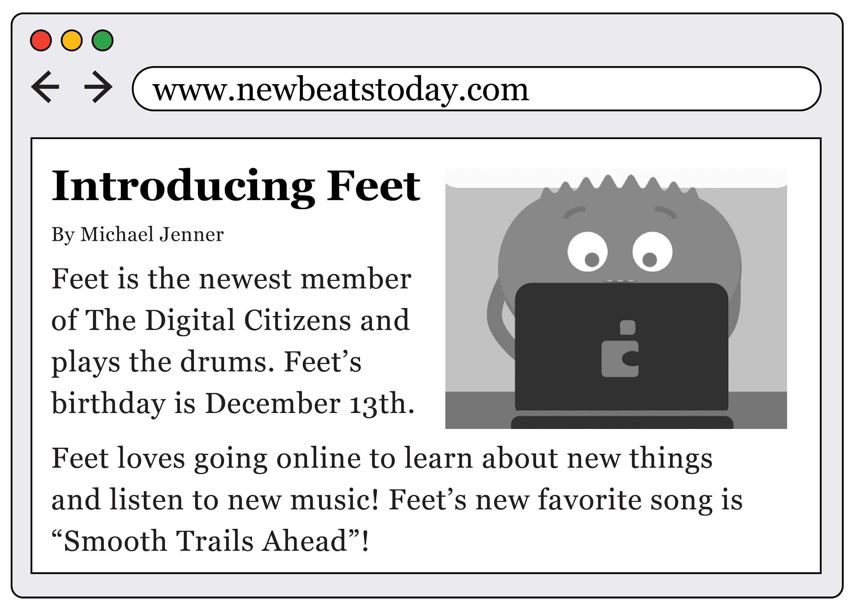

Directions:
Complete the following research report based on the three sites you visited. Don't forget to give credit for the information you used!

Picture:
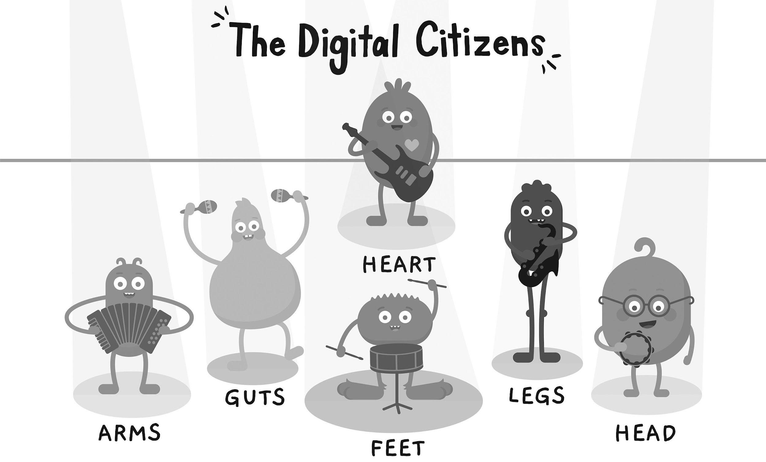

When is Feet's birthday?

What is the band's newest song?

When was their first concert?

How many band members are in the group?

Credits:

Resource 1:

Resource 2:

Resource 3:

